|  |  |
| --- | --- |
| **Problem ID** | SGH074 |

Digital platform for book sharing

|  |  |
| --- | --- |
| **Challenge description with context** | It is required to develop a platform where allumanies and senior faculties can donate their unused books or stationary materials for newly entered students to the institutes. The platform should be capable of showing data of books and its photos. The platform should be capable of showing data of book donor and book done. It should be able to reduce the communication gap between senior students and junior students. |

**Basic idea:**

A digital book sharing platform limited to institute's members where main aim is to reuse the books rather than purchasing them from the market at higher cost. Student's those who cannot afford books can easily get books from this platform and pass it on to someone to the previous year who needs them. Here we will be displayed all the details and the list of the books that are available on the portal and secondly we also be mentioning the condition of the books by adding photo of it and the edition with year so that it becomes easy for user to get the overall condition idea of the books available. This makes easy and affordable way of sharing books and bridges communication gap between junior and seniors.

**Approach to solve:**

The main issue in today's market is getting books on a pocket friendly price. There are many students who have been staying away from their family let it be aboard or different cities. The main problem they face is to arrange finance for themselves to get their day to day lives possible. Just a small help through this project could help them. We tried interacting with each and every sort of students. Where we paused on the main objective apart from their day to day lives was buying books at an affordable range. The approach that we are going to follow is we will ask the faculties and students of the institute to interact with the application and help out students who need them. Faculties and students will have to upload some pictures and description to the book they want to lend/donate. Just one click buy the student (customer) will allow him reserve a book for himself**.**

**Tools and Technologies:**

XAMPP-It allows you to build WordPress site offline, on a local web server on your computer., PHP, MY SQL-Use to store data efficiently, PYTHON-Coding and logic part will be written in python programming language, DJANGO-Framework of python makes easer to build web application, JAVASCRIPT, HTML- HTML is used to create electronic documents (called pages) that are displayed on the World Wide Web. Each page contains a series of connections to other pages called hyperlinks. CSS and BOOTSTRAP for sheet styling, AWS, WORDPESS.

**Project Framework**

-Python Django

**Initial Deployment (LOCAL)**

-Using Bitnami **Django Stack**

-OR

-Using **CherryPy**

**Additional Local Deployment Options**

-Xampp with tweaks

-Wamp

**Production Deployment**

-On Cloud

-On Windows/Linux/Mac

-On Virtual Machines

**Project Abstract for Django Framework**

Main files

* Html
* Css
* Javascript
* SQL/ORM
* Python

Font files

* Eot
* Svg
* Ttf
* Woff
* Woff2

Image files

* Jpg/Jpeg
* Png
* Gif
* ico

**Types of Sub-Applications (Split as per-in Django)**

* + - Admin
    - Database
    - Users
    - Shipping Cart
    - Products
    - Home

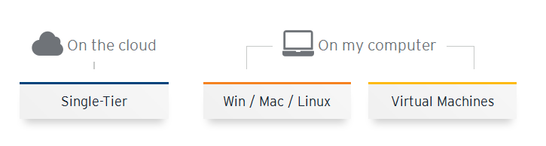



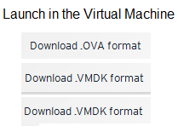

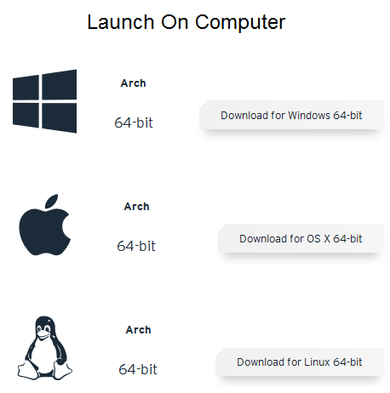

**Login Panel**

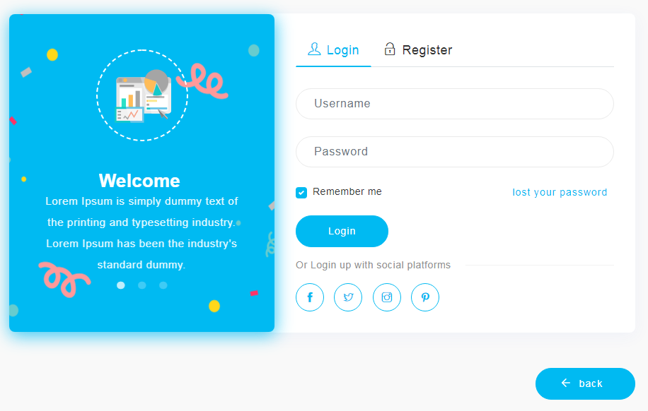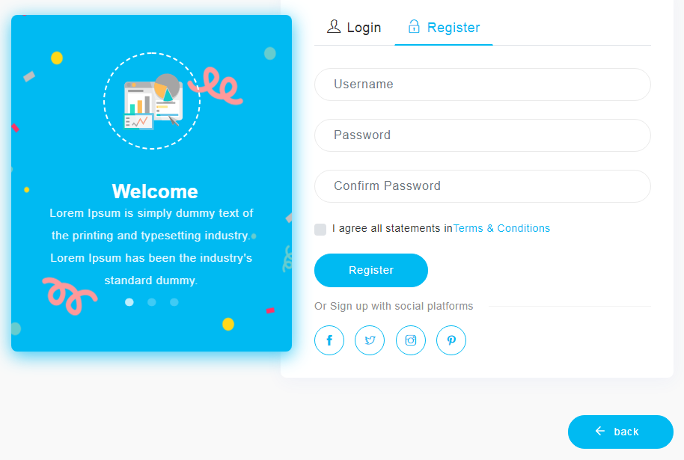

**Home Page (Un-edited Demo)**

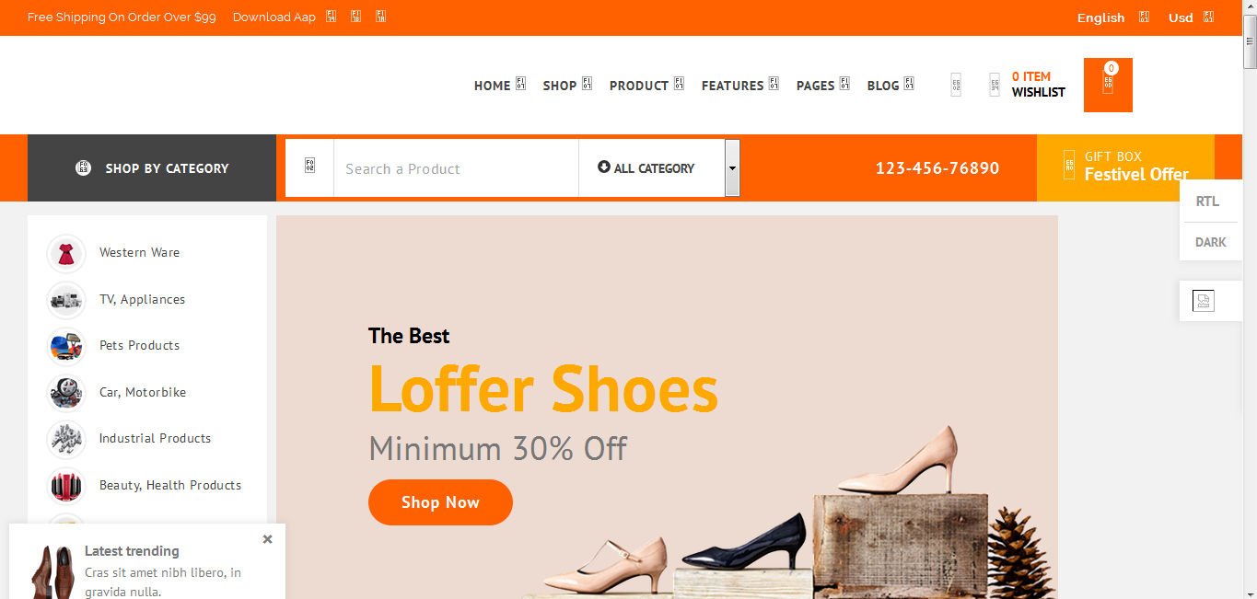



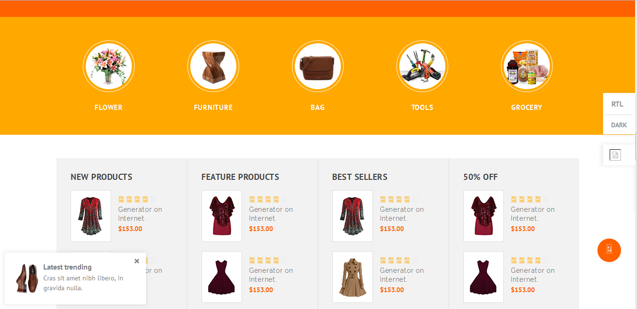

**Admin Dashboard**

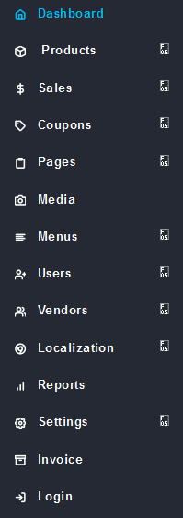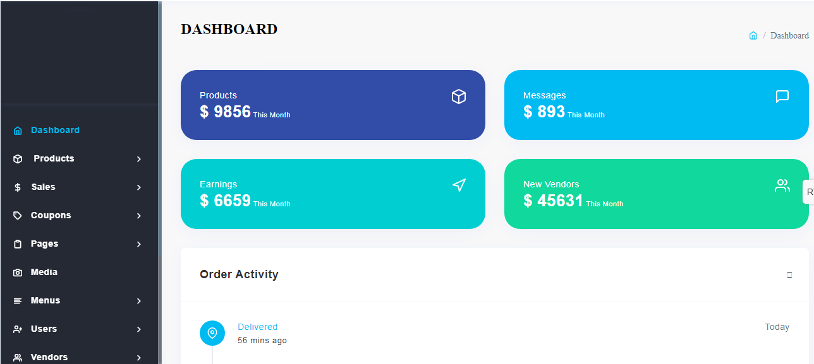

**User Interaction**

**(Changeable as per requirement)**

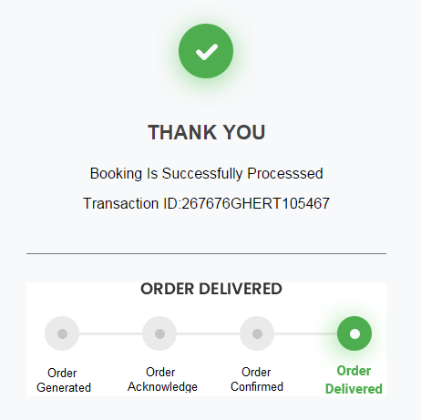

**Final user on-page Notification (Un-edited)**

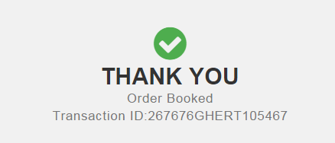

**Challenges faced up till now / future challenges:**

We have face many challenges and risk on implementing our idea to create final prototype and they are:

1. Custom coding to get accurate features.
2. Security and privacy issues.
3. Scope of the website.
4. Data collection, migration, storage…
5. Cross platform compatibility.
6. Website ability to multitask.
7. Website mapping.
8. Integration with 3rd party systems like server.
9. Idea of reducing gap between senior students and junior students.

**Expected outcome:**

We will provide a maintenance free platform such as web application for them where seniors students and any person will donate his/her book for helping needy one’s. There would be an extra add-on feature, where they can also donate book for some limited time period so that they can have it back, so unused books and printouts of study material will be helpful to students and that eliminates the disposal at low rates by pastiwala. The books that are available in the market and are expensive, if available with any student help others to gain knowledge. Waste of paper and money of printing study material and journals can be decreased. Thus inventory of books will increase for the whole institute, through being distributed.